**2025 RLA EMEA Summit**

25th June –26th June

Marriott Amsterdam

Exhibitor Information Book

**Contents:**

Exhibitor Checklist

Venue Info & Booking Your Hotel Room

Register your staff & customer/clients

Set Up / Breakdown time

Shipping

What is included in your package?

Contact List

Floorplan

**Exhibitor Checklist**

|  |  |  |
| --- | --- | --- |
| Item | Order Form/Contact | Due Date |
| Logo for On-site Branding | Ensure your logo is correct  [Here](https://rla.org/event/289#sponsors) | **Immediately** |
| Accommodation  Discounted Rate must use [Book A Room](https://rla.org/event/348) to book | Marriott Amsterdam  [Book A Room](https://rla.org/event/348) | Deadline for room discount rate May 20, 2025 |
| Registrations | See Page 3 | Tue, Jun 25th  Wed, Jun 26th |
| Shipping | Ship to:  Marriott Amsterdam Hotel Stadhouderskade 12, 1054 ES, Amsterdam  Conference: 2025 RLA EMEA Summit  Conference Date: Jun 25 - 26  c/o: Banquet Department  Exhibitor Table: xxx  (Must show all the above with correct table #) | To Avoid misplacement or loss of shipment:  Item can only arrive on or after Jun 22nd, 2025  **Do not ship any boxes to the hotel before Sunday June 22nd.** |
| Setup | Studio 3,4,5,6,7 | Wed Jun 25, 2025 8:00 – 11:00 |
| Breakdown | Studio 3,4,5,6,7 | Thu Jun 26, 2025 17:00 – 19:00 |
|  | 180cm | Table |
| Included in Package | Table in Studio 3,4,5,6  2.5m x 2.5m x 2.58m  Table in Studio 7  2.5m x 2.5m x 2.47m | Estimated overall area with table |
|  | 1 | Chair |
| Power/Electricity | Studio 3,4,5,6,7  Standard Electric outlet on the wall. | Bring your own Extension cable. Can rent for €25 each per day from hotel |

**FREQUENTLY ASKED QUESTIONS**

**Where is the event being held?**

* RLA EMEA Summit is being held at the **Marriott Amsterdam**
  + Stadhouderskade 12 Amsterdam, Netherlands 1054 ES

**Do you have discounted rooms for attendees?**

* Yes, Marriott is the official housing accommodation provider for this event
* Must use this [Book A Room](https://rla.org/event/348) Link to get the €319++ Rate
* Deadline to receive this room rate May 20, 2025

**Questions?** Contact the Marriott Amsterdam Hotel at + 31 20 607 5555

**Please visit Hotel** [**site**](https://www.marriott.com/en-us/hotels/amsnt-amsterdam-marriott-hotel/overview/) **for:**

* Direction to the hotel
* Parking information
* Property Details
* Hotel Services & Amenities

**Where do I get my RLA badge?**

* You can collect your RLA badge at RLA Registration desk Located at the Events & Meeting floor at the hotel.
* All you need to pick up your RLA event Badge at the RLA registration desk are as follows:
  1. Your Identification Card (I.D.)
  2. Your business card with your Name and Company Name that you used registered on RLA website

**What time does registration open?**

* Registration officially opens at 8:00 am on Wednesday, June 25 and 7:30 and Thursday, June 26. Once you receive your badge on the first day, you do not need to check in at the registration desk again the next day.

**Can I register on-site?**

* Yes, you can register on-site, however, we recommend registering in advance to take advantage of early bird pricing and expedite your check-in process.

**What are the conference hours?**

**Wednesday, June 25**

* + Registration: 8:00 am – 17:30
  + Conference & Exhibition Hours: 13:00 – 17:30
  + Evening Reception Hour: 17:30 – 19:00

**Thursday, June 26:**

* + Registration: 7:30 am – 17:00
  + Conference & Exhibition Hours: 8:45 – 17:00

**Where can I view the conference agenda?**

* The full schedule and agenda can be found on the website [here](https://rla.org/event/348) or in the Mobile Event app. Please note you do not need to register for sessions in advance.

**When can I download mobile event app?**

* Two weeks before the event, the mobile event app should be ready for download.

* Scan the QR code to download the app two weeks before the event.

**Will food and beverage be provided?**

* Food and drink will be available during the duration of the event.

**Do I need to order cleaning?**

* The venue will provide basic cleaning of the public areas, however if you require booth cleaning that can be purchased.

**What insurance do I need?**

* Exhibitors are reminded that their insurance for goods and exhibits should take effect from the day that such goods are delivered to the exhibition venue and such insurance should remain in force until their exhibits are removed.

Exhibitors are required to take out adequate insurance cover against the kinds of risks they will incur in connection with the exhibition, especially Public Liability, All Risks on Property, Employer’s Liability and Personal Accident to Staff.

**Is the exhibition hall locked overnight?**

* Yes. The venue provides a basic level of security. We recommend that small handheld valuable equipment be removed daily or locked out of sight when you are not at your booth. Although all care is taken, your own insurance is necessary.

**Who is my RLA Contact?**

* Contact your Advisor

Exhibit Hall Layout: (Layout may change. Please check RLA [website](https://rla.org/reservation/create?event=348&type=3) to view the most updated Floor Plan)

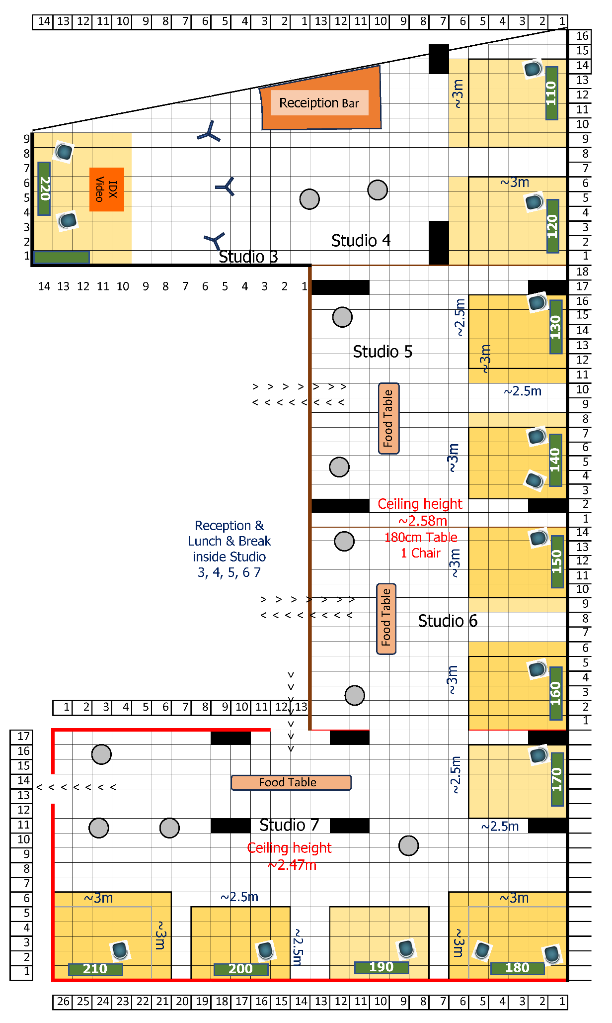

**RLA 2025 EVENT APP for EMEA Summit**

The event app will be shared and launched two weeks before the event start date. On the app, there will be a live map of the exhibit hall, plus details on each of the exhibitors. Exhibitors will be able to connect with attendees, send messages, and

schedule meetings through the APP with attendees who log on.

**An invite with a direct link to Upload and Submit your company profile to the Mobile Event App will be sent to you from Webex Event.**

**Please fill in your company profile on the Mobile Event App as soon as possible, and before May 5th so your company can be well represented as an exhibitor and as a sponsor on the event app.**

* **Square image of your logo** - 1:1 Ratio / Minimum: 500px by 500px / Maximum: 1000px by 1000px
* **Label/Subtitle:** One Short Sentence to highlight your company e.g: Leader in electronics and material lifecycle management.
* **Company Description:** Grab your reader’s attention with a great quote or use this space to emphasize a key point.
* **Booth cover image:** an image to represent your company when they click on the details of your booth. jpg or png 800px by 400px
* **Content Provider:** If you like you can share a link to a public YouTube or Vimeo video
* **Calls to Action – On-site follow up contact Email:**
* **Schedule Meeting URL:** e.g.:Calendely
* **External Links:** Website address, phone# and/or email
* **Attachment:** A one‐page brochure, or other docs you want the user of the app to see. formats: PDF, JPG, TIFF, PNG

**GIVE YOUR EXHIBIT TABLE LOCATION VISIBILITY BEFORE, DURING, & AFTER THE EVENT**

Share your involvement at RLA 2025 European Summit on social media, on your company website, newsletters, emails and press releases. Be sure to use our 2025 hashtag **#RL2025EMEA** and tag us on these social media outlets:

**LINKEDIN:** Reverse Logistics Association https://www.linkedin.com/company/reverse-logistics-association/

**TWITTER:** @RL_Association https://twitter.com/RL_Association

**FACEBOOK:** @ReverseLogisticsAssociation <https://www.facebook.com/ReverseLogisticsAssociation/>

**HOTEL/TRAVEL ARRANGEMENT INFORMATION**

Planning to stay at the Marriott Hotel? Reservations should be made well in advance. We are granted a limited rooms with discounted room rate at €319++ including hot breakfast, your staff should register with the hotel by **May 20th** using the Marriott/RLA online [**Link**.](https://www.marriott.com/event-reservations/reservation-link.mi?id=1729065761635&key=GRP&guestreslink2=true)